|  |
| --- |
| Alexandre Bescond  Master student  alexabes@student.matnat.uio.no  Etienne Bernoux  Master student  etiennb@student.matnat.uio.no |
|  |

|  |
| --- |
| **Assigmnent 3**  **INF5040 - Open distributed processing**  Autumn semester 2017 |

Table of contents

1. Observation 2

1.1 Ring 2

1.1.1 Clustering information 2

1.1.2 Average path length 3

1.1.3 In-degree 4

1.2 Star 5

1.2.1 Clustering information 5

1.2.2 Average path length 6

1.2.3 In-degree 7

2. Conclusion 7

# Observation

## Ring

### Clustering information

The clustering information tell us about how the nodes are distributed and connected each other. Lower this value is, better our peer is distributed.

If the value is too high, the system might separate the peer network into different part e.g. some nodes will not be able to communicate each other.

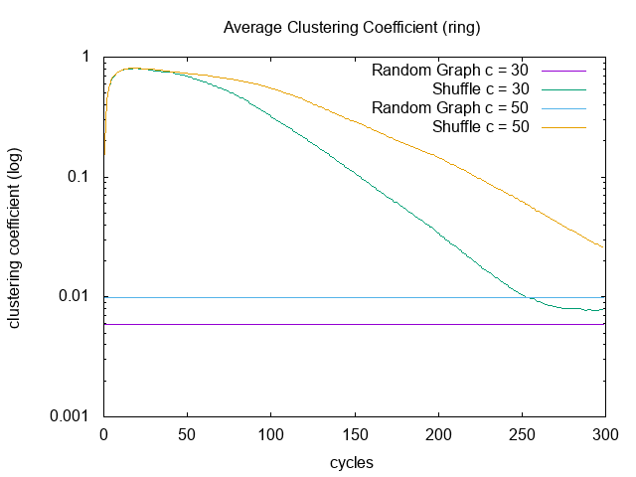

Figure 1: average clustering coefficient with ring topology

First, we can see that our Basic Shuffle algorithm converge to the random distribution. We can notice that with smaller we converge faster than a bigger cache. The reason might be that is easier to shuffle a small cache.

Besides, with the smaller cache, we get a better clustering rate.

### Average path length

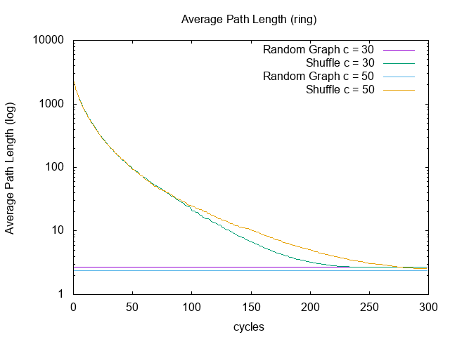

Figure 2: average path length with ring topology

Like the clustering information, the average path of the Basic Shuffle algorithm converges to the random distribution.

With a smaller cache, we converge faster than a bigger cache. However, after 100 cycles we get a smaller average path with the 50-size-cache.

### In-degree

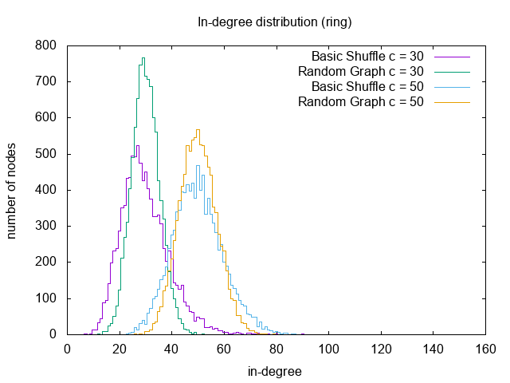

Figure 3: in-degree distribution with ring topology

At the end of the simulation, we obtain approximal the same values than the random distribution.

This is a good thing because it means that our nodes are randomly distributed.

We can notice that the size of the cache corresponds to the peak of the curve. This can be a usefull information for building a distributed application.

## Star

### Clustering information

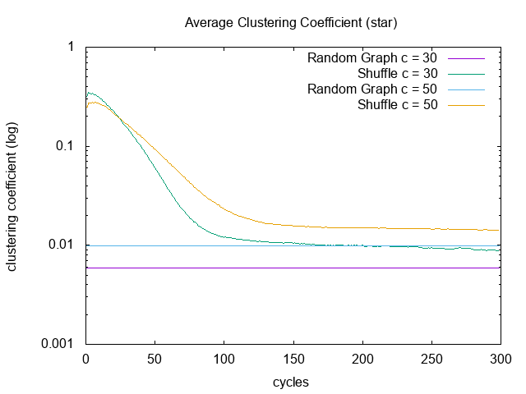

Figure 4: average clustering coefficient with star topology

COMMENTS

### Average path length

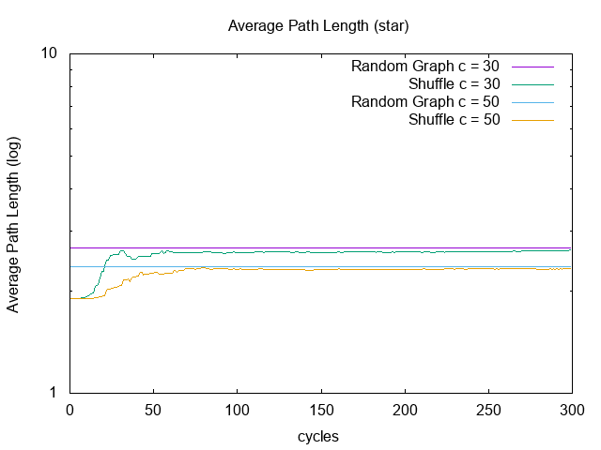

Figure 5: average path length with star topology

Like the ring-based, we converge random distribution. Whatever the size cache, we converge in the same way.

We can add that at the beginning of the simulation, the average path was better.

### In-degree

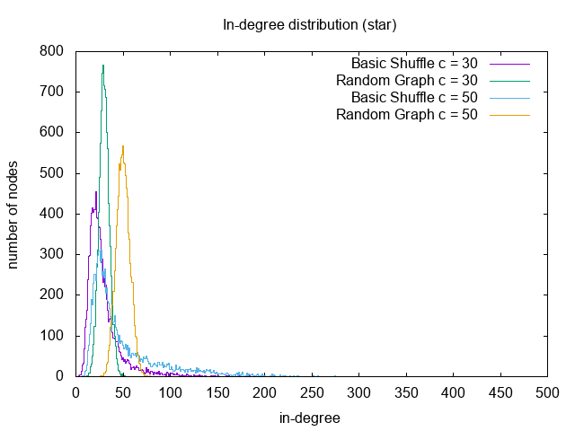

Figure 6: in-degree distribution with star topology

COMMENTS

# Conclusion

To sum up,